**Communication Labs**

**Spring 2023**

**Assignment 4**

**Dumb Choices Only**

Prepared by:

Pauline Wee (pkw2013)

Daria Shokayeva (ds6058)

Swostik Pati (sp6441)

Aja Šačić (as15471)

Instructor:

Dr Evi Mansor

Table of contents

1. INTRODUCTION 3

2. MEET THE TEAM 3

3. PHASE ONE: PLANNING 4

***3.1*** ***Brainstorming Story Ideas*** 4

**3.2** **The Story Atmosphere and Scenes** 6

4. PHASE TWO: DESIGN 6

**4.1** **Story Outline and Video** 6

**4.2** **Recording the Scenes** 8

**4.3** **Website Design** 10

5. PHASE THREE: IMPLEMENTATION 11

**5.1** **Video Editing** 11

**5.2** **Website Development** 12

6. PHASE FOUR: DELIVERY 13

7. REFLECTION 13

8. APPENDIX 16

list of figures

Figure 1 Initial storyboard (page 1) 5

Figure 2 Initial storyboard (page 2) 5

Figure 3 Initial storyboard (page 3) 6

Figure 4 Storyboard (page 1) 7

Figure 5 Storyboard (page 2) 7

Figure 6 Storyboard (page 3) 7

Figure 7 Storyboard (page 4) 7

Figure 8 Behind the scenes of the team struggling to set up the camera 8

Figure 9 Interactive Media Lab Still 9

Figure 10 Visual Design Lab Still 9

Figure 11 Lobby Still 10

Figure 12 Wireframe 10

Figure 13 Desktop view 12

Figure 14 Phone view 12

List of tables

Table 1 Three Week Overview Plan 14

# **INTRODUCTION**

The project was focused on producing video in order to create an immersive story or experience. In this unique endeavor, the team aims to captivate and engage viewers through an interactive experience. The video, ranging from 3 to 6 minutes in duration, serves as a dynamic foundation for user interaction. Featuring a multitude of scenes that branch based on user decisions on the team's website, this production unveils a series of unfortunate events. However, there's a twist: to achieve the best ending, users are challenged to deliberately choose the worst option at each turn. Users can expect an immersive journey filled with unexpected choices and thrilling outcomes. They can dive into the captivating narrative and unravel the hidden gems of the "worst" decisions.

Beyond the suspense and intrigue, this interactive video production aims to provide a unique form of entertainment that engages the audience on multiple levels. By actively involving viewers in decision-making, we foster a sense of agency and emotional investment, transforming the viewing experience into a collaborative adventure.

Overall, this video production project is a testament to the team's commitment to pushing the boundaries of storytelling and embracing new forms of audience engagement. It offers a thrilling and immersive journey that combines the thrill of interactive storytelling with the artistry of video production. By challenging conventional storytelling norms and embracing audience participation, the team seeks to offer a unique form of entertainment that captivates and engages viewers on multiple levels.

# **MEET THE TEAM**

|  |  |
| --- | --- |
|  |  |
| **Pauline**  **Leader, Actress, Video editor** | **Darian**  **Actress, Web Development** |
|  |  |
| **Swostik**  **Lead Web Development, Actor, Video Filming** | **Ajla**  **Actress, Video editing** |

# **PHASE ONE: PLANNING**

## ***Brainstorming Story Ideas***

The first team meeting served as a platform for generating ideas for the project. Given that none of the team members had a background in video production or a natural inclination towards it, the initial step posed considerable challenges. Generating an original idea is a struggle for most individuals, regardless of their specialization, so the process wasn't as straightforward as anticipated. However, the collective brainstorming session proved beneficial as four minds proved to be more effective than one during the ideation process. By leveraging their diverse backgrounds, such as Jiu-Jitsu, the team devised a concept for their project titled "Dumb Choices Only," which involved portraying comedic short stories. To adhere to the project's time constraints of three to six minutes, the team focused on condensing the narrative and excluding extensive backstories, emphasizing originality. Consequently, they developed a concise three-part story that prioritized visual elements for the project. To conclude the initial brainstorming session and transition to the main phase of the project, video production, the team utilized a piece of paper to document their progress, building upon the conceptualization of the story illustrated on the whiteboard during the meeting (Figure 1-3).

|  |
| --- |
| Letter, calendar  Description automatically generated  Figure Initial storyboard (page 1) |
| Figure Initial storyboard (page 2) |
| Figure Initial storyboard (page 3) |

## **The Story Atmosphere and Scenes**

The initial brainstorming session allowed the team to think of the filming atmosphere and the scenes that were going to make up the biggest bulk of the project. Since the project is intended to develop a sense for video production, the team thought of having three different interactive scenarios that would develop an immersive narrative and show the importance of the decision making. Although none of the team members are performing arts majors, acting was stressed to be the path taking to finish the project. The brainstorming session for the project was very productive as it immediately set the team on their route to officially set off on their project which, as of then, constituted a compelling story with three unique paths. Drawing inspiration from the lives of Interactive Media students, the team crafted stories that were set in their homebase, i.e., the Arts Center at NYUAD. Each story was distinct, reflecting the diverse lives of the students, but they were all united by a common theme: illogical choices are to be chosen. The team left the session feeling energized and excited to bring these stories to life on screen. By designating for roles within the story, namely the student, killer, friend and the professor, all team members were able to fill a role such as to fully engage with the story and video production.

# **PHASE TWO: DESIGN**

## **Story Outline and Video**

To start off the design phase, the team developed a detailed storyboard (Figure 4-7) which helped them visualize all of the scenes that need to be filmed for the project. It also allowed them to map the locations of the cameras within the filming locations. The scenes were developed.

|  |  |
| --- | --- |
| Figure Storyboard (page 1) | Figure Storyboard (page 2) |
| Figure Storyboard (page 3) | Figure Storyboard (page 4) |

# 

# Although the story was already set up, the team was keen on adding more details to the story such a “Mission passed” and “Wasted” screen that are present in GTA (Grand Theft Auto) games all of the team members enjoyed while growing up.

To record the video, the team initially thought of getting a GoPro camera to be able to record first person perspective. After obtaining the camera from the Equipment Center, the team faces multiple obstacles while trying to set up the camera (Figure 8). The camera, although primarily indented to record first person perspective, shoot in “fisheye” lens which was not the look with which the project was envisioned. Having realized that no GoPro cameras are available during their filming period, the team booked a standard camera which was recommended for the project. Although the camera is quite bulky, it was still a very powerful machine that was able to aid the team during the project. Since the team was able to attend the video workshop that happened a few weeks prior to the onset of the project, there were minor difficulties that occurred while filming which were mainly related to the initial setup of the camera.

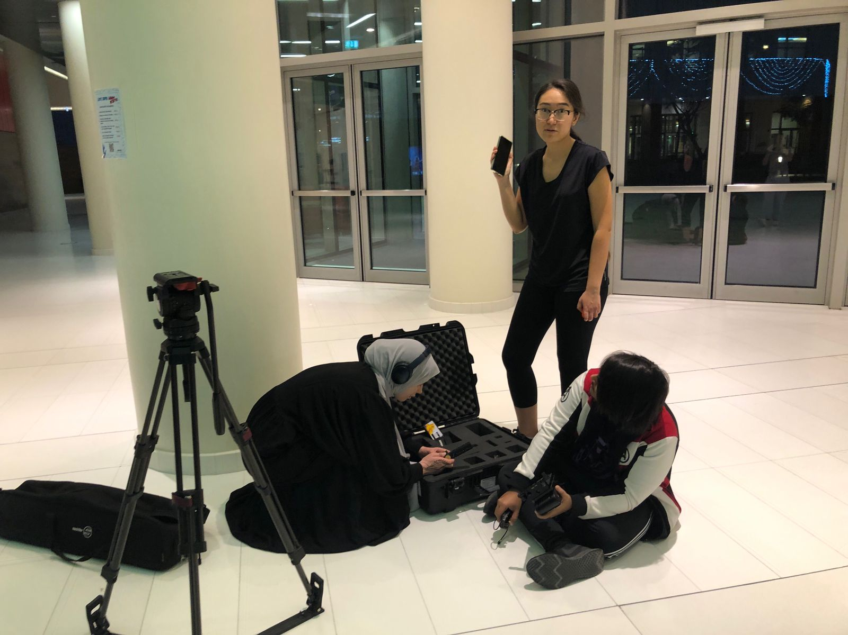

Figure Behind the scenes of the team struggling to set up the camera

## **Recording the Scenes**

The scenes were recorder in the NYUAD Arts Center, namely, the lobby, Visual Design Lab, and the Interactive Media Lab, as well as the various hallways that connect the spaces. The team choose the nighttime to record the videos such as to correctly emulate the different atmospheres which primarily relate to scenes during the night. Figures 9 to 11 show the three different filming locations that are present within the project.

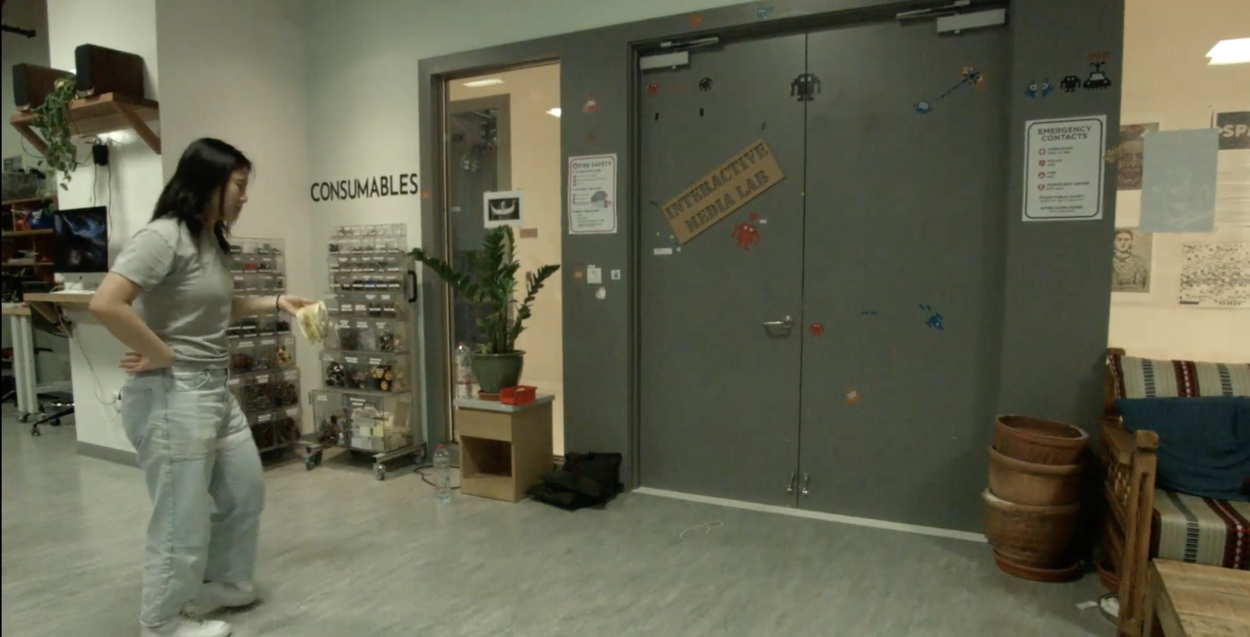

Figure Interactive Media Lab Still

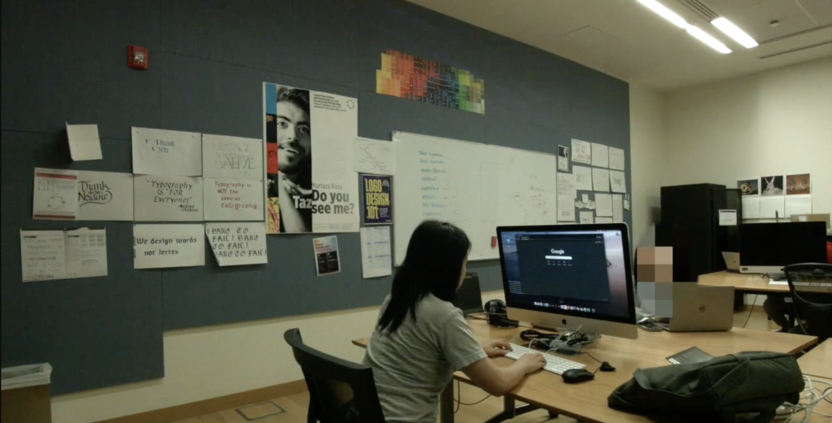

Figure Visual Design Lab Still

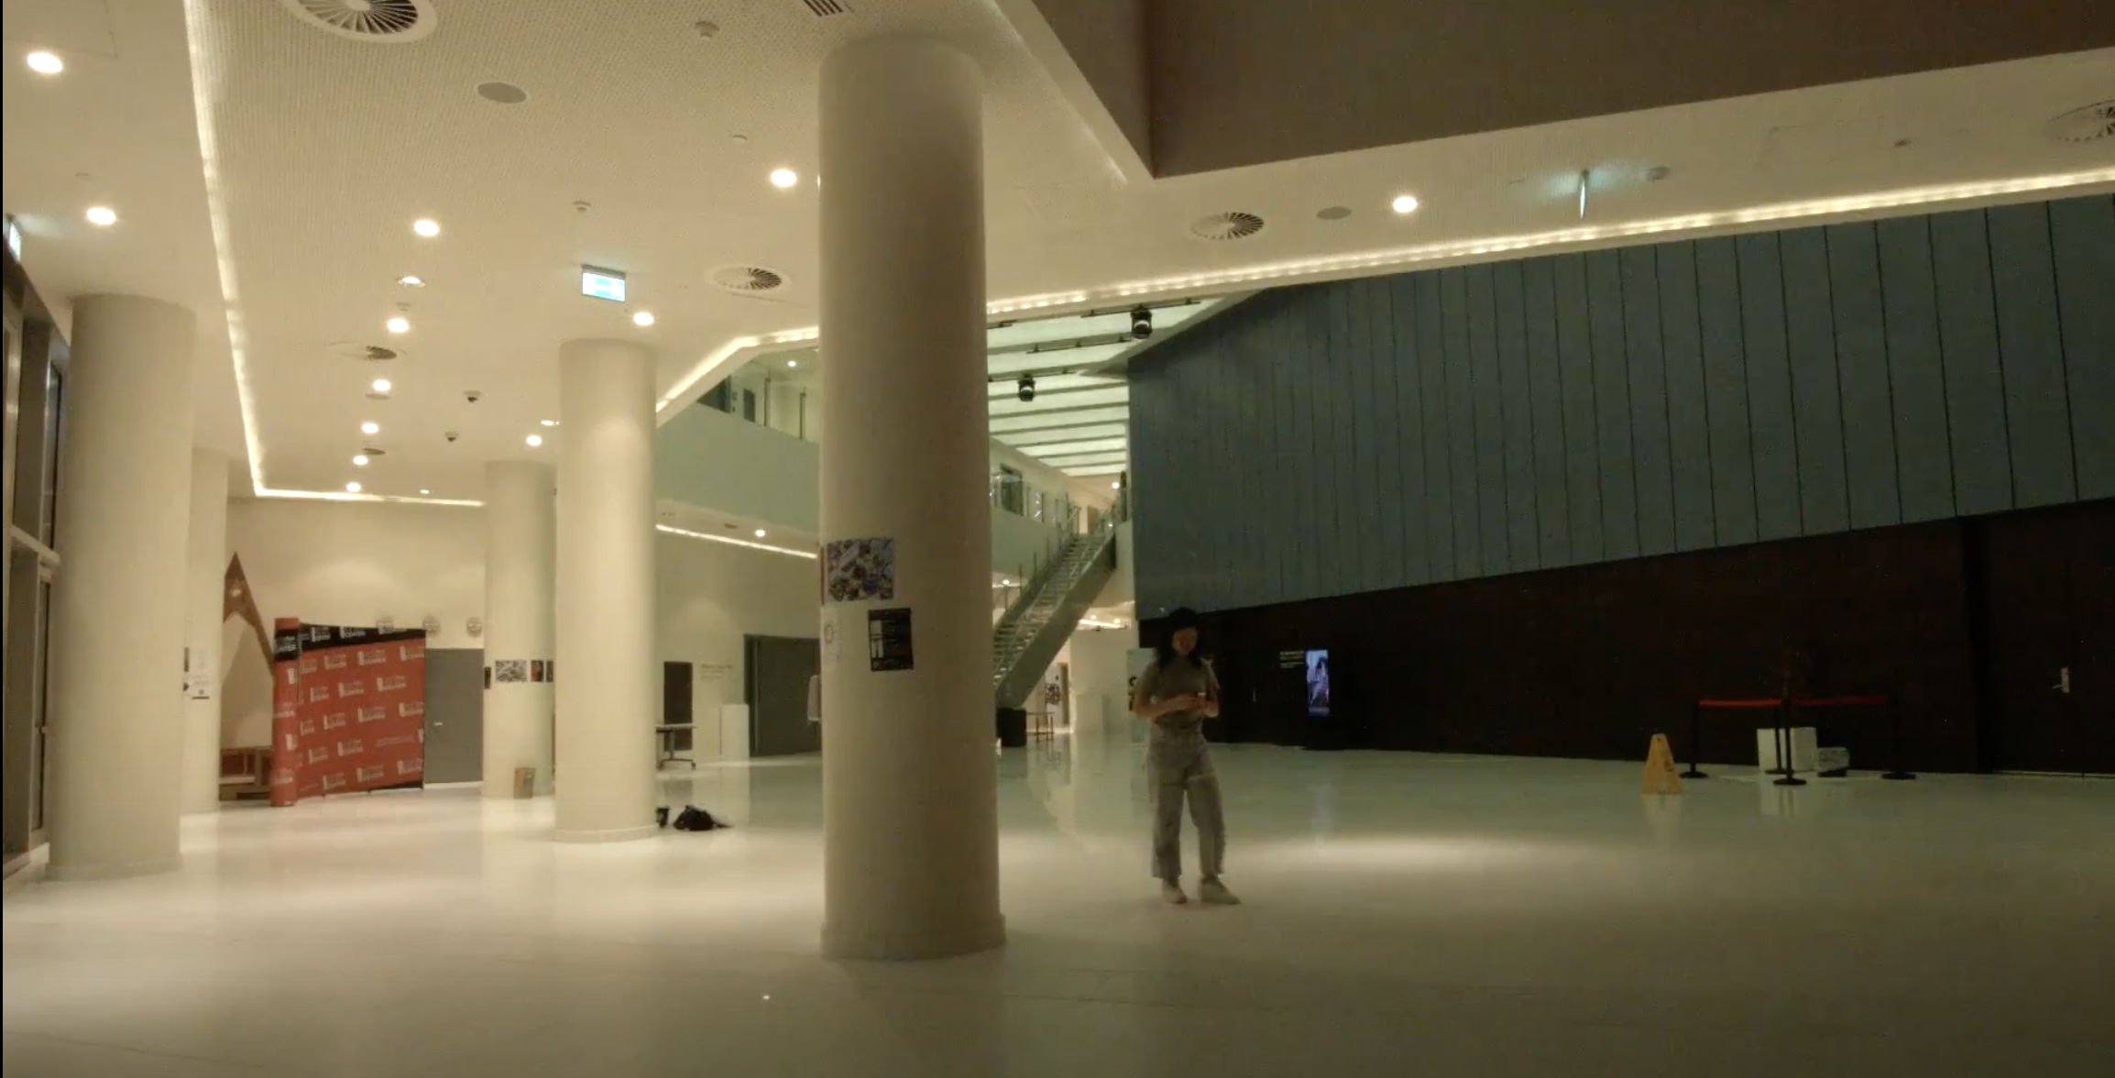

Figure Lobby Still

## **Website Design**

Since the focus of the assignment was primarily video production, the team decided to make the website like a nest for it. In order to reduce distractions, the website was designed to be very simple, without many buttons to press. This would effectively prompt the user to continue on the three different journeys and experience each one by restarting the path. To begin the website implementation, the team first created a simple wireframe (Figure 12) that would help them map the individual elements later on.

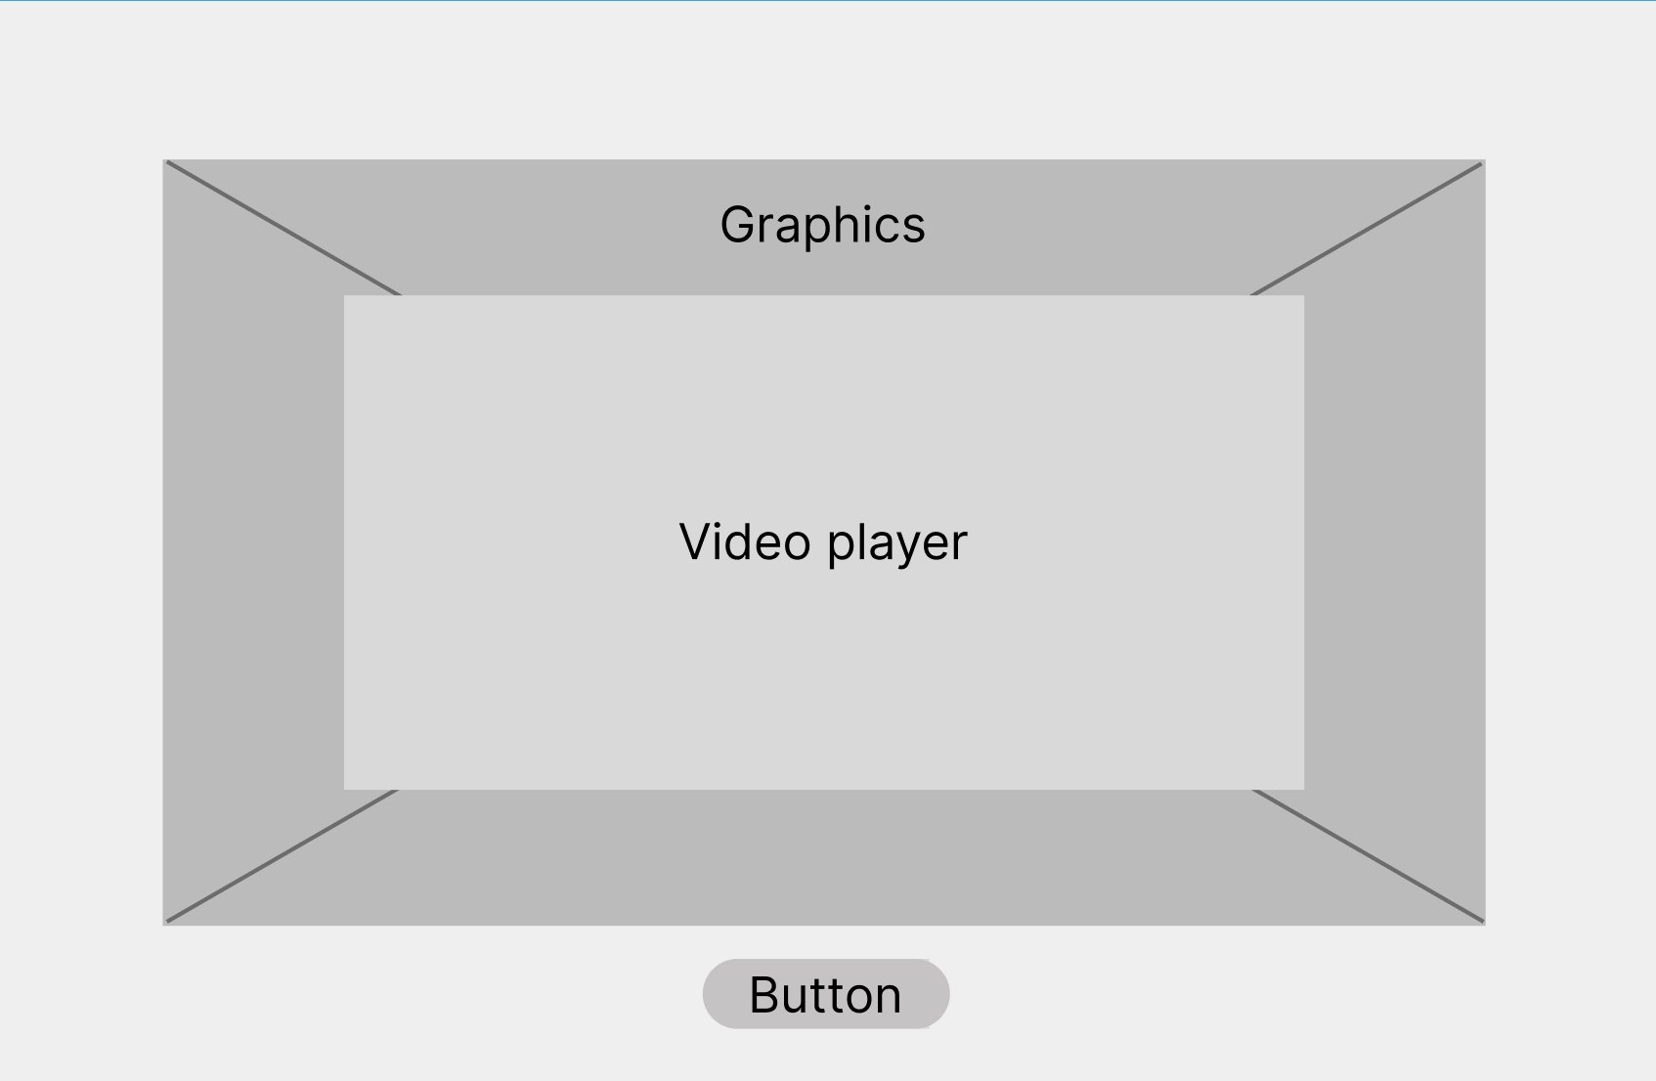

Figure Wireframe

# **PHASE THREE: IMPLEMENTATION**

## **Video Editing**

To edit their videos, the team used iMovie. Since the scenes did not require an immense amount of editing, the software served its purpose without overwhelming the members, few of whom have ever extensively edited movies. By importing the footage recorded a few days prior into iMovie, the team was able to

Editing involved selecting relevant clips, then cutting them to the appropriate length. The types and angles of shots were also varied: sometimes, POV shots were used, while sometimes third person shots were used. Editing mostly focused on trying to keep the general motion and progression of the clips consistent. Meanwhile, audio mostly involved a mix of sound from the original clips and original voiceovers by the main actor. Because the original audio was usually noisy or not quite effective, background noise reduction was used, and voiceovers and some audio sounds such as a gunshot sound were added during editing in order to enhance the experience.

The background image was designed in order to show the title and theme of the video. To make the website responsive, the team provided both the background photo for the desktop (Figure 13) and mobile (Figure 14) viewing. The colors chosen are playful and bright, and humorous memes and illustrations from the varying stories are used to reinforce the theme. For example, the banana, computer, banana peel, a solitaire card, and a punching glove were drawn to reference the action points from all three branching universes.

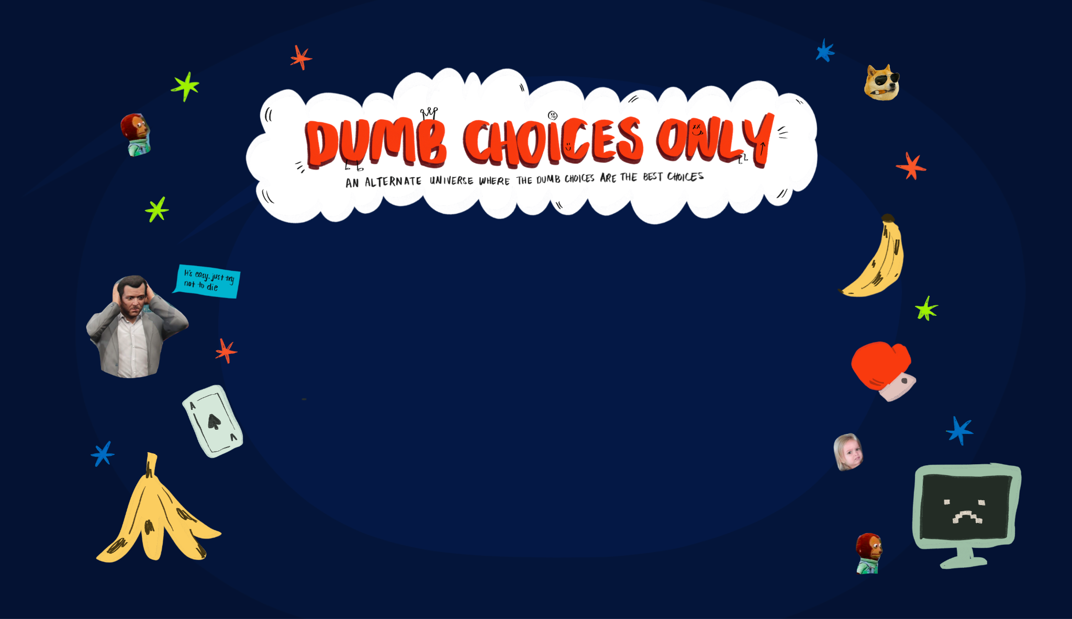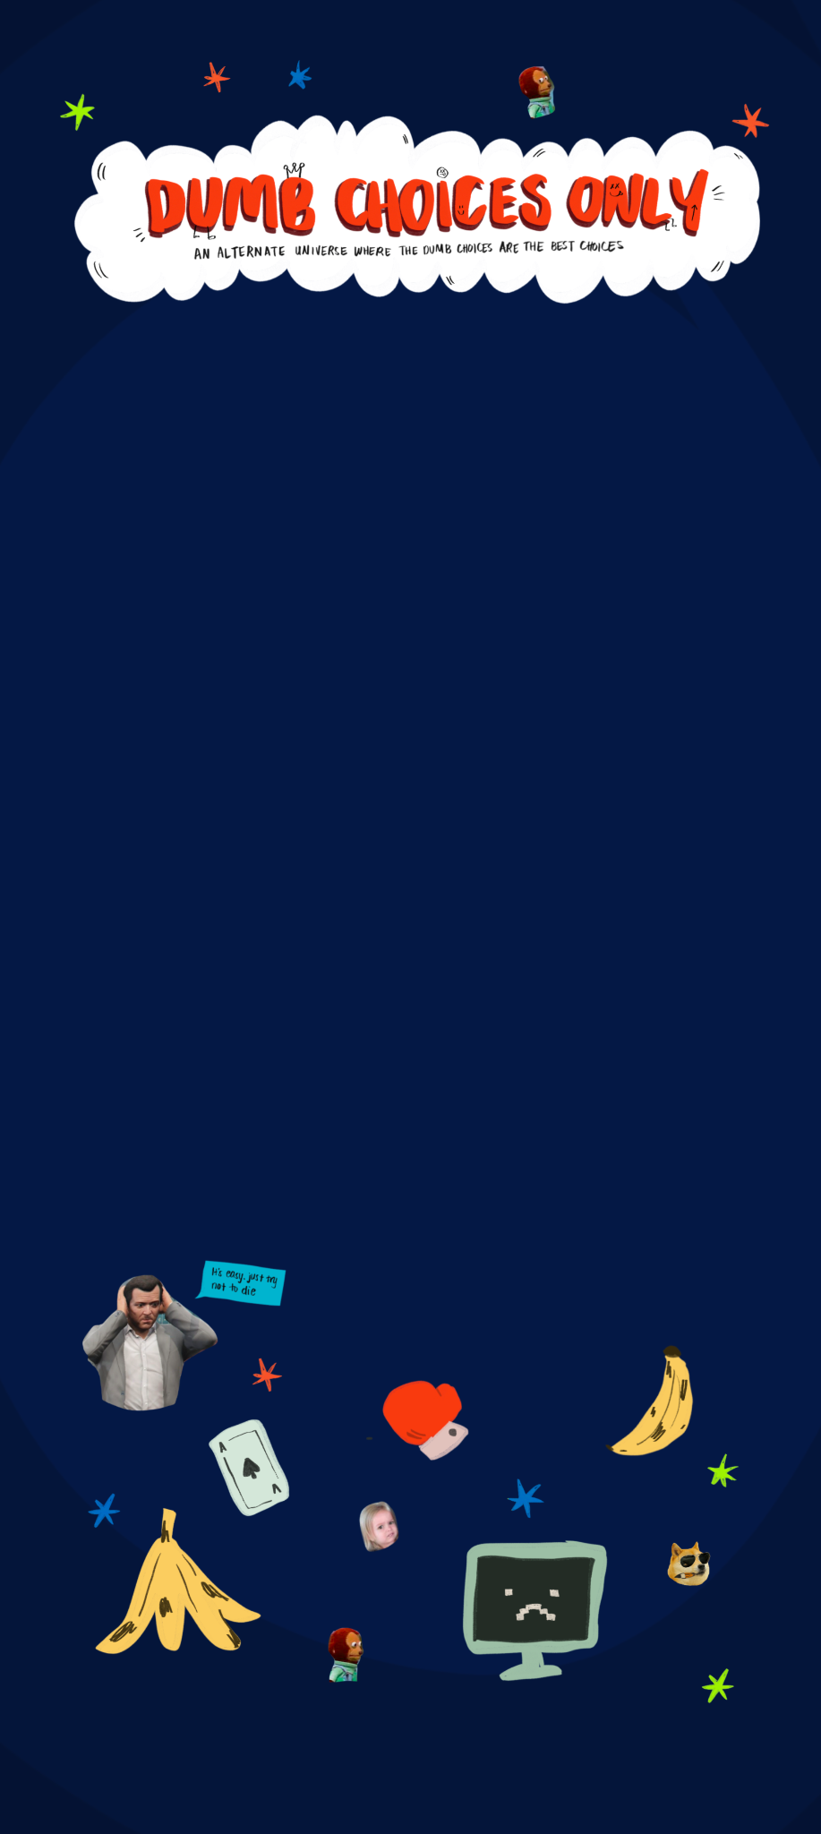

Figure Desktop view

Figure Phone view

## **Website Development**

An important aspect of the video production project was the planning and implementation of the website. The primary objective was to create a simple, yet intriguing user experience by seamlessly integrating videos and interactive menus. To achieve a seamless flow, event listeners were incorporated into the website. The listeners were programmed to detect the ending of each video, triggering the display of two or three menus which designated the choices users were able to make. By implementing event listeners, the website could dynamically respond to user actions, enhancing interactivity and engagement. This allowed users to navigate through the content effortlessly and provided them with a sense of control over their “destiny”.

The videos and menus were organized in a specific order to ensure a smooth and logical progression of the interactive videos. Careful consideration was given to the narrative enabled by the videos and the desired user journey. Each video was strategically placed to build upon the previous one, creating a coherent and immersive storyline. This sequencing not only helped convey the intended message effectively but also maintained the user's interest and engagement. The team made sure that the video was responsive and functional across all devices. By managing the file sizes, the team ensured that the website would load in a reasonable time and that the GitHub repository could hold the files, which amounted to more than 2GB of data at the onset of the project.

# **PHASE FOUR: DELIVERY**

The last phase was the delivery phase. This phase consists of a few steps, namely, the publishing of the website, its testing, and the writing of documentation. All members of the team tested the functionality of the website by visiting the repository on GitHub Pages. The delivery phase also included presenting the website during the Communications Lab class.

# **REFLECTION**

The project offered a completely new experience for the team members. Considering nobody in the team had ever worked with filming video before, the project gave the team an opportunity to delve into the fascinating world of creating both videos and interactive storylines. The experience has, thus, been both challenging and rewarding, pushing the boundaries of the team’s creativity and technical skills.

One of the most valuable lessons learned during the project was the importance of collaboration. By working with a diverse team, different perspectives and expertise were brought together to produce a satisfactory end product. Through open communication and effective teamwork, the team was able to navigate challenges and capitalize on each other's strengths.

One of the most powerful aspects of video production is telling engaging stories. Throughout the project, the team focused on creating an engaging narrative that captivated the audience. By carefully crafting the sequence of videos and menus, the team aimed to take viewers on a journey with the protagonist. The team also wanted to create an immersive experience where users could connect with the content on a deeper level and. The project highlighted the impact of storytelling and emphasized the significance of interactivity in video production.

Table Three Week Overview Plan

|  |  |  |  |
| --- | --- | --- | --- |
| **Plan** | Week 1 | Week 2 | Week 3 |
| - Practice storytelling fundamentals |  |  |  |
| - Brainstorming Idea |  |  |  |
| - Brainstorm scenes |  |  |  |
| - Create storyboard/script |  |  |  |
| - Allocate design/implementation roles |  |  |  |
| **Design** |  |  |  |
| - Design settings and coordinate scenes |  |  |  |
| - Prepare filming locations |  |  |  |
| - Ideate auditive aids |  |  |  |
| - Find needed props |  |  |  |
| - Design website |  |  |  |
| **Implementation** |  |  |  |
| - Edit video |  |  |  |
| - Add the video to website |  |  |  |
| - Add interactive components to website |  |  |  |
| - Organize GitHub repository |  |  |  |
| - Run GitHub website |  |  |  |
| **Delivery** |  |  |  |
| - Publish the website |  |  |  |
| - Write documentation |  |  |  |
| - Submit project on Brightspace |  |  |  |
| - Present in class |  |  |  |

# **APPENDIX**

***index.html***

|  |
| --- |
| <!DOCTYPE html>  <html>  <head>  <meta charset="UTF-8">  <title>Dumb Choices Only</title>  <link rel="stylesheet" href="style.css">  <link href="https://fonts.googleapis.com/css?family=Montserrat&display=swap" rel="stylesheet">  </head>  <body>  <div id="video-container">  <button id="replay-button"> Replay </button>  <!-- intro video -->  <video id="video_player1" class="video-player" controls>  <source src="./assets/videos/intro_new.mp4" type="video/mp4">  </video>  <!-- first three options -->  <!-- visual design studio -->  <video id="video_player2" class="video-player" controls>  <source src="./assets/videos/design_lab.mp4" type="video/mp4">  </video>  <!-- im lab -->  <video id="video_player3" class="video-player" controls>  <source src="./assets/videos/im_lab.mp4" type="video/mp4">  </video>  <!-- lobby -->  <video id="video_player4" class="video-player" controls>  <source src="./assets/videos/lobby.mp4" type="video/mp4">  </video>  <!-- second level options - design studio -->  <!-- sleep -->  <video id="video_player5" class="video-player" controls>  <source src="./assets/videos/design_lab_sleep.mp4" type="video/mp4">  </video>  <!-- work -->  <video id="video_player6" class="video-player" controls>  <source src="./assets/videos/design_lab_work.mp4" type="video/mp4">  </video>  <!-- second level options - im lab -->  <!-- inside -->  <video id="video_player7" class="video-player" controls>  <source src="./assets/videos/im_lab_inside.mp4" type="video/mp4">  </video>  <!-- outside -->  <video id="video_player8" class="video-player" controls>  <source src="./assets/videos/im_lab_outside.mp4" type="video/mp4">  </video>  <!-- second level options - lobby -->  <!-- punch -->  <video id="video_player9" class="video-player" controls>  <source src="./assets/videos/lobby_punch.mp4" type="video/mp4">  </video>  <!-- get punched -->  <video id="video_player10" class="video-player" controls>  <source src="./assets/videos/lobby_getpunched.mp4" type="video/mp4">  </video>  <!-- respect -->  <video id="respect" class="video-player" controls>  <source src="./assets/videos/respect.mp4" type="video/mp4">  </video>  <!-- wasted -->  <video id="wasted" class="video-player" controls>  <source src="./assets/videos/wasted.mp4" type="video/mp4">  </video>  </div>  <div id="menu1" class="menu">  <p class="select_text"> Pauline should:</p>  <ul>  <li id="vd_studio">  <p>Work in the Design Studio</p>  </li>  <li id="im_lab">  <p>Hangout in the IM lab</p>  </li>  <li id="lobby">  <p>Hangout in the Lobby</p>  </li>  </ul>  </div>  <div id="menu2" class="menu">  <p class="select_text"> Pauline should:</p>  <ul>  <li id="vd_studio_sleep">  <p>Take a nap</p>  </li>  <li id="vd_studio_work">  <p>Work on assignment</p>  </li>  </ul>  </div>  <div id="menu3" class="menu">  <p class="select_text"> Pauline should:</p>  <ul>  <li id="im_lab_inside">  <p>Throw the peel on the floor</p>  </li>  <li id="im_lab_outside">  <p>Throw the peel outside</p>  </li>  </ul>  </div>  <div id="menu4" class="menu">  <p class="select_text"> Pauline should:</p>  <ul>  <li id="lobby_punch">  <p>Randomly punch</p>  </li>  <li id="lobby_getpunched">  <p>Keep walking</p>  </li>  </ul>  </div>  <script src="app.js"></script>  </body>  </html> |

***app.js***

|  |
| --- |
| window.addEventListener('load', () => {  video_player1.style.display = 'block';  });  video_player1.addEventListener('ended', **function** () {  menu1.style.display = 'flex';  });  video_player2.addEventListener('ended', **function** () {  menu2.style.display = 'flex';  });  video_player3.addEventListener('ended', **function** () {  menu3.style.display = 'flex';  });  video_player4.addEventListener('ended', **function** () {  menu4.style.display = 'flex';  });  video_player5.addEventListener('ended', **function** () {  video_player5.style.display = 'none';  respect.style.display = 'flex';  respect.play();  });  video_player7.addEventListener('ended', **function** () {  video_player7.style.display = 'none';  respect.style.display = 'flex';  respect.play();  });  video_player9.addEventListener('ended', **function** () {  video_player9.style.display = 'none';  respect.style.display = 'flex';  respect.play();  });  video_player6.addEventListener('ended', **function** () {  video_player6.style.display = 'none';  wasted.style.display = 'flex';  wasted.play();  });  video_player8.addEventListener('ended', **function** () {  video_player8.style.display = 'none';  wasted.style.display = 'flex';  wasted.play();  });  video_player10.addEventListener('ended', **function** () {  video_player10.style.display = 'none';  wasted.style.display = 'flex';  wasted.play();  });  vd_studio.addEventListener('click', **function** () {  video_player1.style.display = 'none';  menu1.style.display = "none";  video_player2.style.display = 'block';  video_player2.play();  });  im_lab.addEventListener('click', **function** () {  video_player1.style.display = 'none';  menu1.style.display = "none";  video_player3.style.display = 'block';  video_player3.play();  });  lobby.addEventListener('click', **function** () {  video_player1.style.display = 'none';  menu1.style.display = "none";  video_player4.style.display = 'block';  video_player4.play();  });  vd_studio_sleep.addEventListener('click', **function** () {  video_player2.style.display = 'none';  menu2.style.display = "none";  video_player5.style.display = 'block';  video_player5.play();  });  vd_studio_work.addEventListener('click', **function** () {  video_player2.style.display = 'none';  menu2.style.display = "none";  video_player6.style.display = 'block';  video_player6.play();  });  im_lab_inside.addEventListener('click', **function** () {  video_player3.style.display = 'none';  menu3.style.display = "none";  video_player7.style.display = 'block';  video_player7.play();  });  im_lab_outside.addEventListener('click', **function** () {  video_player3.style.display = 'none';  menu3.style.display = "none";  video_player8.style.display = 'block';  video_player8.play();  });  lobby_punch.addEventListener('click', **function** () {  video_player4.style.display = 'none';  menu4.style.display = "none";  video_player9.style.display = 'block';  video_player9.play();  });  lobby_getpunched.addEventListener('click', **function** () {  video_player4.style.display = 'none';  menu4.style.display = "none";  video_player10.style.display = 'block';  video_player10.play();  });  **const** replayButton = document.getElementById("replay-button");  replayButton.addEventListener("click", **function**() {  location.reload();  }); |

***style.css***

|  |
| --- |
| body {  **background-image**: url('./assets/images/background.png');  **background**-**size**: cover;  **background-repeat**: **no-repeat**;  }  **#video-container** {  **display**: flex;  **position**: **relative**;  **width**: **100**%;  **height**: **100**vh;  }  video {  **position**: **absolute**;  **display**: **none**;  **top**: **50**%;  **left**: **50**%;  transform: translate(**-50**%, **-22**%);  **max-width**: **50**%;  **max-height**: **50**%;  }  **.select_text**  {  **background-color**: **rgb**(**15**, **43**, **82**);  **border**: **2px** **solid** **#f1c40f**;  **color**: white;  **position**: **absolute**;  **justify**-**content**: **center**;  **top**: **15**%;  **padding**: **20px**;  **border**-radius: **30px**;  **font-family**: 'Montserrat', **sans-serif**;  **text-transform**: **uppercase**;  **font-size**: **24px**;  **text-align**: **center**;  **letter-spacing**: **1px**;  **text-decoration**: **none**;  transition: all **0.2s** ease-in-out;  }  **.menu** {  /* display: flex; */  **display**: **none**;  **width**: **100**%;  **height**: **100**%;  **background-color**: rgba(**0**, **0**, **0**, **0**.**8**);  **position**: **absolute**;  **top**: **0**;  **left**: **0**;  **justify**-**content**: **center**;  align-items: **center**;  }  **.menu** ul {  **list-style**: **none**;  **display**: flex;  /* flex-direction: column; */  align-items: **center**;  /* justify-content: space-between; */  }  **.menu** li {  /* margin: 10px 0; */  **padding**: **50px**;  }  **.menu** li p  {  **display**: **inline**-**block**;  **padding**: **20px**;  **border**: **2px** **solid** white;  **border**-radius: **30px**;  **background-color**: **#f1c40f**;  **color**: **rgb**(**15**, **43**, **82**);  **font-family**: 'Montserrat', **sans-serif**;  **text-transform**: **uppercase**;  **font-size**: **24px**;  **text-align**: **center**;  **letter-spacing**: **1px**;  **text-decoration**: **none**;  transition: all **0.2s** ease-in-out;  }  **.menu** li p**:hover** {  **background-color**: **rgb**(**15**, **43**, **82**);  **border**: **2px** **solid** **#f1c40f**;  **color**: white;  }  **#replay-button** {  **display**: **inline**-**block**;  **margin**: **0** **auto**;  **position**: **absolute**;  **bottom**: **2**vh;  **left**: **50**%;  transform: translate(**-50**%, **-30**%);  **background-color**: **#f1c40f**;  **border**: **2px** **solid** white;  **border**-radius: **30px**;  **color**: **rgb**(**15**, **43**, **82**);  **font-family**: 'Montserrat', **sans-serif**;  **text-transform**: **uppercase**;  **font-size**: **24px**;  **padding**: **10px**; |